**AvanTech YOU from Hettich now with signature lighting**

**High in quality and individually tailored for shop and kitchen**

**Individuality is the freedom to choose. The growing megatrend of individualisation is reinforcing customer demand for customised design flexibility, be it in trendy shop design or in kitchen and home furnishings. The versatile and adaptable AvanTech YOU drawer platform from Hettich meets this contemporary taste and style spot on. The inventor of the drawer platform has now added an attractive design option to its latest system: every drawer can be given its very own LED signature lighting with the "AvanTech YOU Illumination" feature.**

The AvanTech YOU drawer system takes every effort out of individualising design to meet any customer preference in colour, format and material. All components within the platform can be combined with each other, permitting a wide product lineup with lean, flexible production at low costs in manufacturing and stock keeping.

By way of option, AvanTech YOU now even gives furniture its own signature lighting: in clip on profiles, homogeneous LED light at 4,000°K illuminates open drawers on the inside or makes a stunning feature on the outside. Glass inlays with polished or ground edges can also be shown off in the best light: the LED signature creates amazing visual effects every time the drawer is opened. In each case, a practical rechargeable battery pack provides the necessary energy. This eliminates the need for costly and complicated electrical connections - the quality design feature with signature lighting is easy to install and can be realised without any additional effort on the technical side. This exceptional design achievement by Hettich has already won several international accolades, including the "Interzum Award 2021" and the “Red Dot Design Award 2022”.

The cost efficient AvanTech YOU platform gives manufacturers like Nolte Küchen the scope they look for in offering attractive drawer design with an exclusive feel and noticeable quality to discerning kitchen customers in the high end segment too.

**Even more design flexibility**

In a width of just 13 mm, the slimline AvanTech YOU drawer side profile with invisibly integrated front panel adjustment function permits elegant, flawless design in any finish. Even within the standard lineup, the platform provides a huge range of combination options: time and again, clip on DesignProfiles or DesignCapes can be used to create visual highlights with a different look. And drawer side profile inlays provide the key to meeting personal design preferences - even in any material the customer chooses.

The "AvanTech YOU Illumination" feature is a new, attractive addition to Hettich's cost effective drawer platform. For kitchen and furniture manufacturers, this opens up further opportunities to set themselves well apart from the competition and give their discerning customers attractively designed drawers with an exclusive feel and noticeable quality right up into the high end segment.

More about "AvanTech YOU Illumination" from Hettich:   
  
Landing page:   
<https://avantechyou.hettich.com/en/>

Product website:   
<https://web.hettich.com/en-de/products-eshop/drawer-systems/avantech-you>

Video AvanTech YOU Illumination:   
<https://e.video-cdn.net/video?video-id=BRxW9cxp9DwPQTDGS31E55&player-id=8BwzRXWCGzWg75u7mK5EYt&channel-id=1851>

The following picture material is available for downloading from **www.hettich.com, menu: Press**:

**Images**

**Captions**

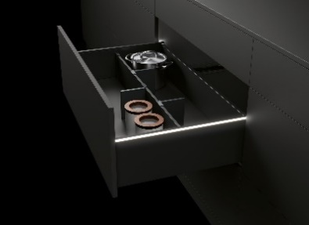

P91_a

Homogeneous LED light in clip on profiles: by way of option: AvanTech YOU Illumination gives furniture its very own lighting signature. Photo: Hettich

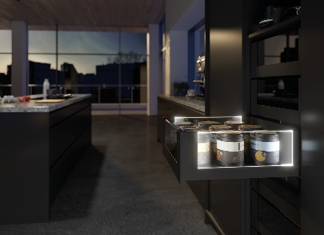

P91_b

AvanTech YOU with LED signature lighting: illuminated glass inlays create stunning effects and a touch of elegance. Photo: Hettich

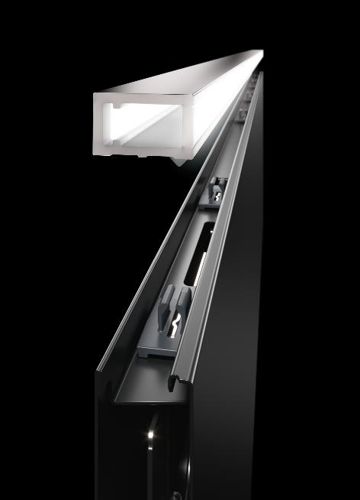

P91_c

Easy to install: the lighting strip of homogeneous LED light in 4,000 K simply clips onto the AvanTech YOU drawer side profile. Photo: Hettich

About Hettich

Hettich was founded in 1888 and is today one of the world's largest and most successful manufacturers of furniture fittings. Over 7,400 members of staff in almost 80 countries work together towards the objective: developing intelligent technology for furniture. Hettich thus inspires people all over the world and is a valuable partner for the furniture industry, trade and craft. The Hettich brand stands for consistent values: for quality and innovation. For reliability and customer proximity. Despite its size and international significance, Hettich has remained a family business. Independent of investors, the company's future is shaped freely, humanely and sustainably. www.hettich.com